3.Design PDA using simulator to accept input string a^nb^2n

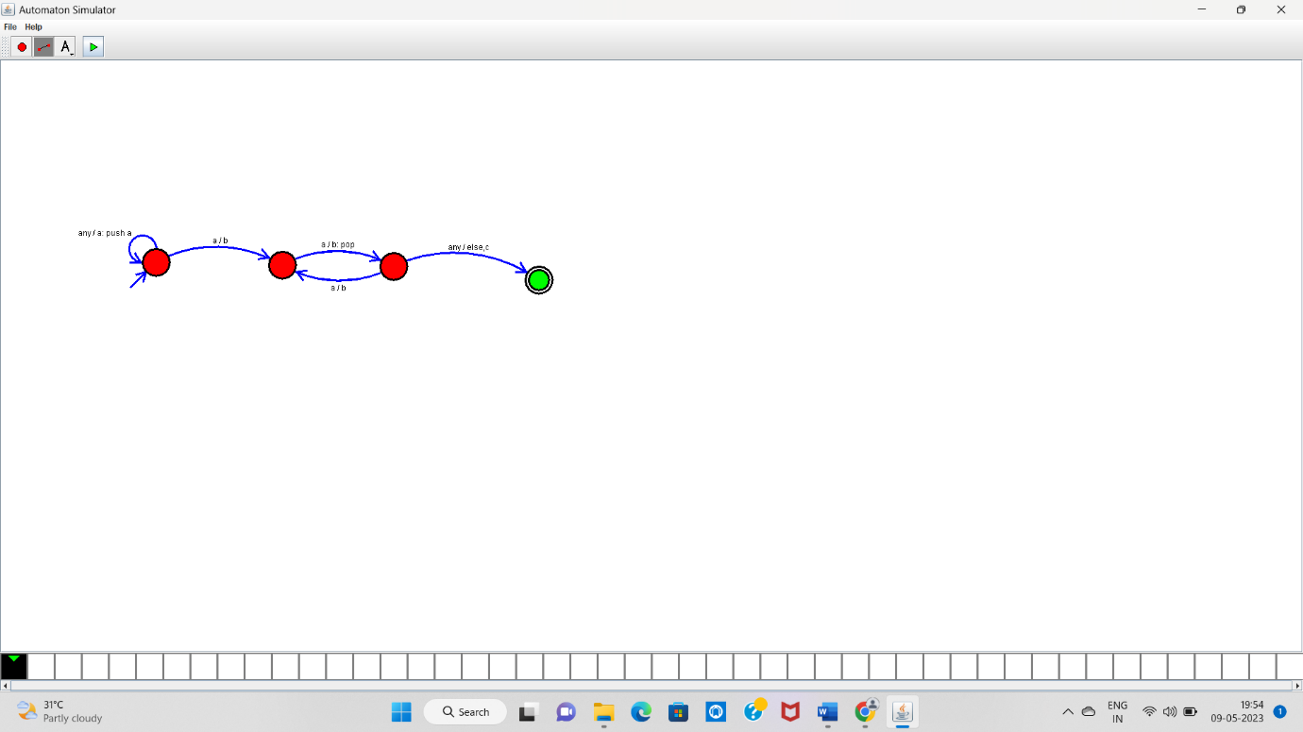

aabbbb-----Accepted